AI Live Meeting Summarizer
Speech Recognition Model Evaluation Report
- Introduction
Automatic Speech Recognition (ASR) and Natural Language Processing (NLP) are core technologies in modern Artificial Intelligence systems. With the rapid increase in virtual meetings (Zoom, Teams, Google Meet), there is a growing demand for systems that can automatically transcribe and summarize conversations.
The AI Live Meeting Summarizer is designed as an end-to-end intelligent system that converts raw meeting audio into structured summaries. The system integrates multiple AI components such as speech recognition, speaker diarization, and transformer-based summarization.
- Objectives
The key objectives of this project include:
    - Develop a pipeline for speech-to-text conversion
    - Compare ASR models using Word Error Rate (WER)
    - Implement real-time transcription
    - Perform speaker diarization (who spoke when)
    - Generate structured meeting summaries
    - Evaluate performance using WER, DER, ROUGE, BLEU
- System Architecture
The system follows a multi-stage pipeline:
    - Audio Input (Dataset / Microphone)
    - Audio Preprocessing
    - Speech Recognition (Vosk / Whisper)
    - Speaker Diarization (Pyannote)
    - Text Cleaning & Processing
    - Summarization (Transformer Model)
    - Evaluation Metrics
- Dataset
The dataset used is the AMI Meeting Corpus, a real-world dataset containing multi-speaker meeting recordings.

Audio File:
    - ES2002a.Array1-01.wav

Reference Files:
    - ES2002a.A.words.xml
    - ES2002a.B.words.xml
    - ES2002a.C.words.xml
    - ES2002a.D.words.xml
- Audio Preprocessing
Audio preprocessing is performed to standardize input for ASR models.
Steps:
    - Convert audio to 16kHz
    - Convert stereo to mono
    - Normalize audio format
    - Process full-length meeting audio Output:
    - Processed audio ready for transcription
- Reference Transcript Generation
Since transcripts are in XML format, preprocessing is required.
Steps:
    - Parse XML files
    - Extract words and timestamps
    - Merge speaker transcripts
    - Generate final reference text Output:
    - reference_trimmed.txt (or full transcript)
- Speech Recognition Models
  - Vosk
    - Lightweight offline model
    - Faster but less accurate
  - Whisper
    - Transformer-based model
    - Better contextual understanding

- Word Error Rate (WER)
WER evaluates transcription accuracy:
WER = (Substitutions + Insertions + Deletions) / Total Words
Interpretation:
    - 0 → Perfect
    - 0.5 → Poor accuracy
- Vosk Evaluation (Full Audio)
    - Reference words: 384
    - Predicted words: 238
    - WER: 0.7578
Analysis:
    - Struggles with noise
    - Poor handling of multiple speakers

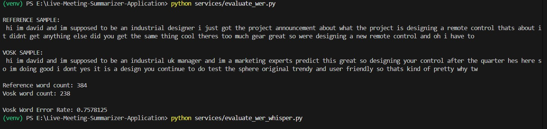
- Whisper Evaluation (Full Audio)
    - Reference words: 384
    - Predicted words: 342
    - WER: 0.7109
Analysis:
    - Better than Vosk
    - Handles context better
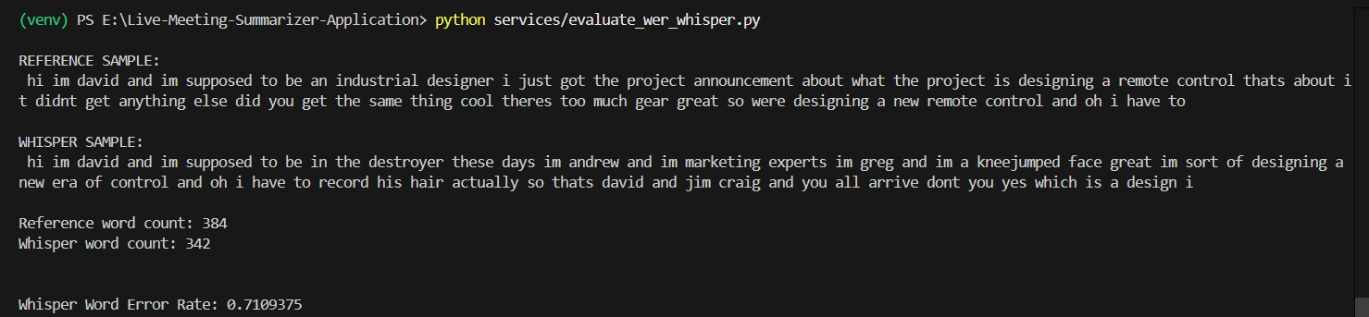
- Model Comparison
Model | WER | Performance
Vosk | 0.7578 | Average
Whisper | 0.7109 | Better

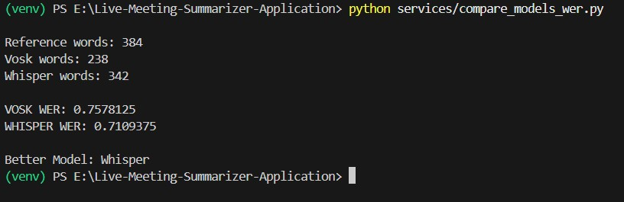
- Real-Time Speech Recognition Process:
    - Record audio using microphone
    - Perform live transcription

Output:
"hello everyone welcome to the meeting" WER:
0.0

Interpretation:
    - Perfect accuracy in clean audio
    - Shows system works well in controlled conditions

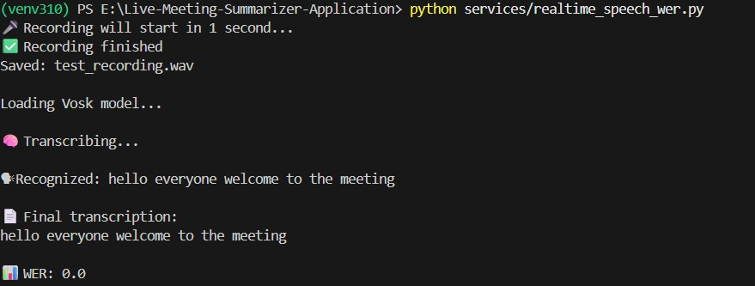
- Speaker Diarization Model:
    - pyannote/speaker-diarization-3.1 Output:
    - Time-based speaker segments Example:
    - 15.07s – 15.18s : SPEAKER_00

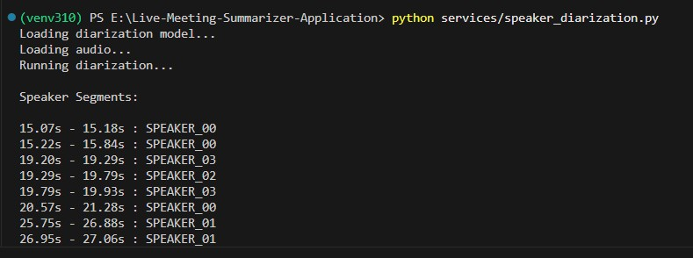
- Diarization Error Rate (DER)
Results:
    - DER: 29.07%(error) , Accuracy : (82%)
    - False Alarm: 11.23%
    - Missed Detection: 15.61%
    - Confusion: 2.23%
Interpretation:
    - Moderate performance
    - Main errors: missed speech
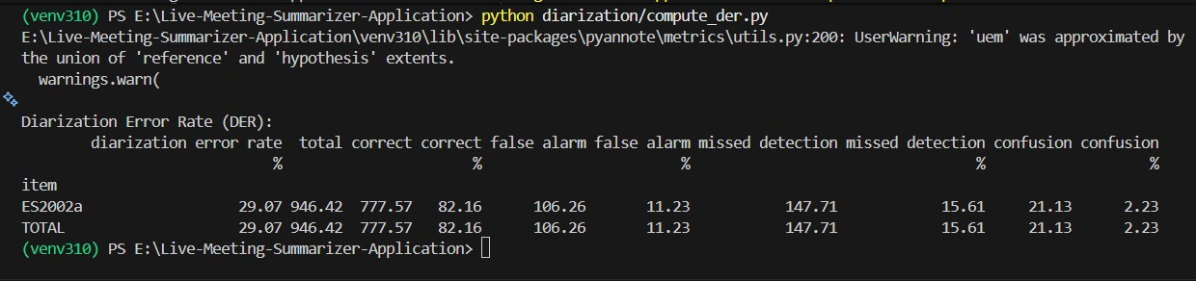
- Meeting Summarization Model:
    - BART (Transformer)
Output:
    - Key points
    - Action items
    - Decisions
Scores:
    - ROUGE F1 ≈ 0.28
    - BLEU ≈ 0.024
Interpretation:
    - Captures meaning
    - Needs improvement
Meeting Summary:
David and Jim Craig are designing a new era of control. The project is a design in your control. There are three different stages to the design. The spear-riching old trendy and user-friendly is the brief. You can take as long as you because we haven't got an awful lot of physical affection. I could totally hold up more but beagles. And then the small kitten for a. And, um, my butt here, it's come real.
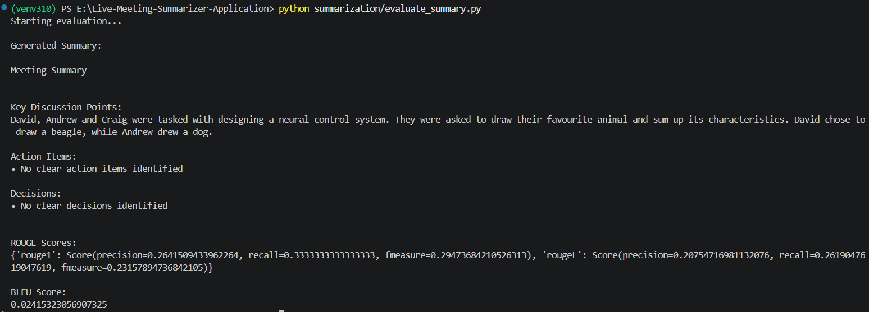
- Reasons for High Error Rates
    - Multi-speaker environment
    - Background noise
    - Far-field microphones
    - Speaker overlap
- Pipeline Integration
The AI Live Meeting Summarizer is designed as an end-to-end pipeline where multiple AI components work together to process meeting audio and generate structured summaries.
Pipeline Flow
1. Audio Input o Pre-recorded audio (AMI dataset) or real-time microphone input 2. Audio Preprocessing
o Convert to 16kHz and mono o Ensures compatibility with ASR models
    - Speech Recognition (ASR) o Vosk (real-time) and Whisper (accurate) o Output: Raw transcript
    - Speaker Diarization o Using Pyannote
o Output: Speaker-labeled segments
    - Transcript Alignment o Combine transcription with speaker segments o Output: Speaker-aware transcript
    - Text Processing & Summarization o Clean and structure text
o BART generates key points, actions, and decisions
7. Evaluation Metrics o WER → Transcription accuracy o DER → Speaker accuracy o ROUGE/BLEU → Summary quality
Integrated Execution
The pipeline is executed using run_pipeline.py, which:
    - Controls the workflow
    - Connects all modules
    - Stores outputs
Final Outputs
    - whisper_output.txt → Transcript
    - diarized_transcript.txt → Speaker-wise text
    - final_summary.txt → Summary
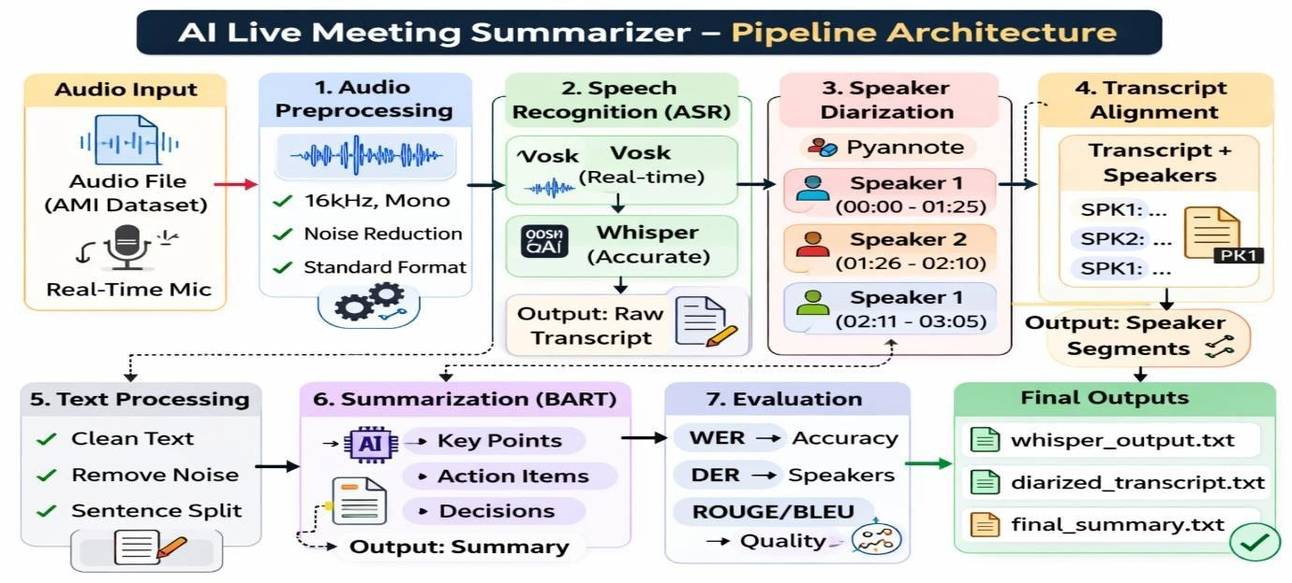

18. Deployment using Streamlit
The AI Live Meeting Summarizer is deployed using Streamlit, a Python-based framework that enables rapid development of interactive web applications for machine learning systems. This allows seamless integration of backend AI models with a user-friendly interface.
🔹 Deployment Architecture
The deployed system consists of:
- Frontend (Streamlit UI):
  - Handles user interaction (recording, display, export, email)
- Backend (AI Modules):
  - Speech Recognition (Whisper)
  - Speaker Diarization (Pyannote)
  - Summarization (BART)
- Processing Pipeline:
  - Triggered after user stops recording

🔹 Application Execution
- The application is launched using:
streamlit run app.py

- It runs locally on:
http://localhost:8501

🔹 Deployment Workflow
- User opens the application
- Starts recording audio
- Live captions are displayed
- User stops recording
- Backend pipeline is executed:
  - Transcription → Diarization → Summarization
- Results are displayed in UI

19. User Interface (UI) Design and Features
The system provides a modern and interactive interface designed using Streamlit. The UI is structured to provide real-time insights and easy access to outputs.
🔹 Main Sections
- Live Captions
- Recording Controls
- Transcript Display
- Summary Display
- Export Options
- Email Integration
- Previous Meetings
🔹 Key Features
- Real-time transcription display
- Speaker-labeled transcript
- AI-generated summary
- Interactive buttons (Start/Stop)
- Clean and responsive design

20. Export Functionality
The system includes an export feature that allows users to download meeting outputs directly from the interface.

🔹 Available Export Options
- 📄 Download PDF
- 📝 Download Markdown

🔹 Exported Data Includes
- Transcript
- Speaker-wise transcript
- Meeting summary

🔹 Implementation
Export functionality is implemented using Streamlit’s download_button, enabling instant file downloads.
21. Email Integration
The system provides an email feature to share meeting outputs.
🔹 Features
- Input field for email address
- Send Email button

🔹 Functionality
- Sends meeting summary and transcript to user email
- Enables easy sharing and collaboration

22. Previous Meetings and Search Functionality
The application maintains a history of past meetings.
🔹 Features
- Displays saved meeting files
- Search bar to filter logs
- “Open” button to view previous meetings

🔹 Benefits
- Easy retrieval of past discussions
- Improves usability and data management

23. System Workflow in Deployment
The deployed system follows a structured execution flow:
- Initialize models
- Wait for user input
- Start recording
- Perform live transcription
- Store audio
- On STOP:
  - Execute full pipeline
- Display outputs

🔹 Control Logic
- Summarization is triggered only after STOP
- Ensures proper pipeline execution
- Avoids partial or incorrect summaries

24. Logging and Data Management
A logging mechanism is implemented to track system operations.
🔹 Logged Data
- Recording events
- Transcription output
- Diarization results
- Summary output

🔹 Storage
- Audio files (.wav)
- Text outputs (.txt)

🔹 Benefits
- Helps debugging
- Maintains meeting history
- Improves reliability

25. Performance Analysis in Deployed System
🔹 Observations
- Whisper provides high transcription accuracy
- Real-time captions work effectively
- Diarization performs moderately
- Summarization captures key ideas

🔹 Limitations Observed
- Sensitive to background noise
- Difficulty in overlapping speech
- Increased latency for long meetings

26. Challenges Faced
🔹 Technical Challenges
- Synchronizing multiple AI modules
- Managing real-time audio processing
- Handling model loading delays

🔹 System Challenges
- Diarization errors
- Summary inconsistencies and high CPU usage
27. Real-World Applications

The system can be used in:
- Corporate meetings
- Online education
- Legal documentation
- Healthcare discussions
- Customer service analysis

28. Future Enhancements
- Use Whisper Large model
- Improve noise reduction
- Enhance diarization accuracy
- Deploy on cloud (AWS/Azure)
- Add multilingual support
- Improve UI/UX

29. Conclusion
The AI Live Meeting Summarizer successfully demonstrates the integration of multiple AI technologies into a unified real-time system. The deployment using Streamlit enables interactive usage, allowing users to convert raw meeting audio into structured summaries efficiently.
The system performs well in controlled environments and provides meaningful insights such as transcripts, speaker identification, and summaries. Although challenges such as noise sensitivity and diarization accuracy remain, the system establishes a strong foundation for future intelligent meeting assistants.
GitHub URL =https://github.com/SpringboardMentor050/Live-Meeting-SummarizerApplication/tree/Shivam-Kumar

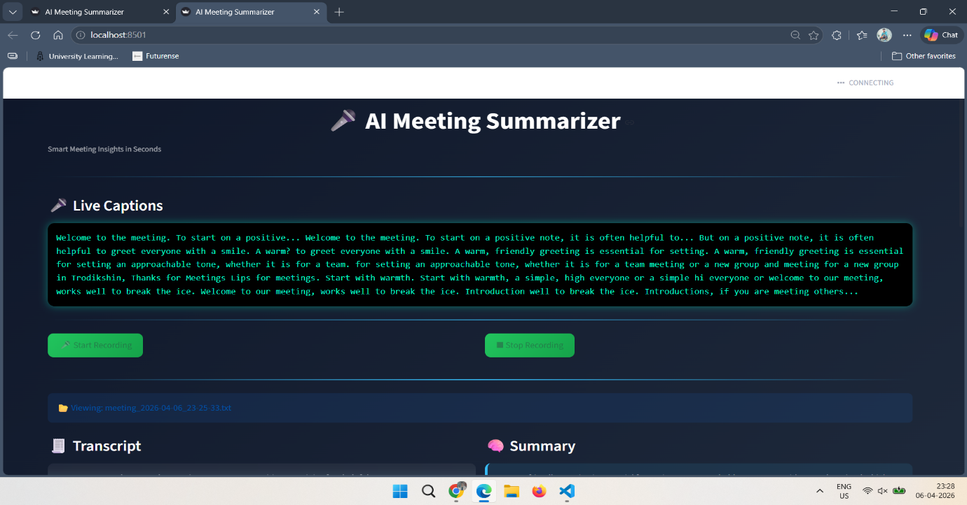
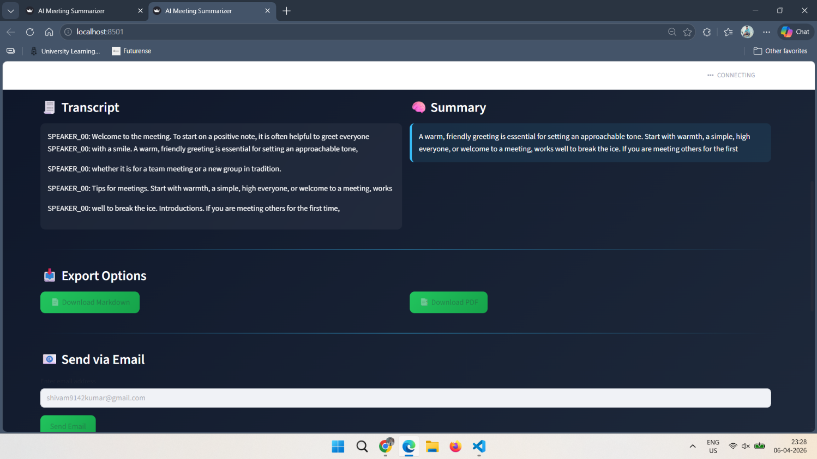

s